**Bug on Page ‘www.bonify.de​’:**

**Issues 3:**

On '**https://www.bonify.de/bonitaet**' Page, though I have converted the text on the page to EN The images on the page should change based on language selection.

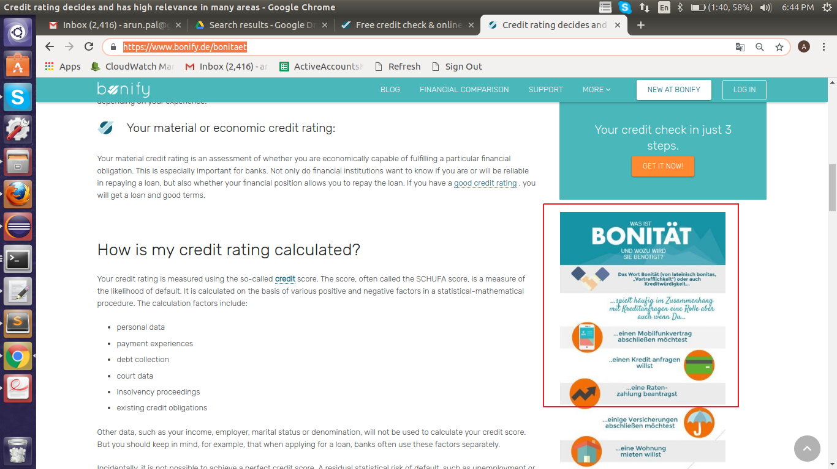

**Steps To Reproduce:**

1: Start Chrome Browser with url **‘https://www.bonify.de/bonitaet’.**

2: Scroll down to page to locate the image.

**Expected Result:** Images (text) should display in EN if site is converted to EN.

**Actual Result:** Although site is converted to EN images (text) are displaying in DE.

**Browser:** Chrome (Version 70)

**OS:** Ubuntu (16)

**Priority:** P3

**Assign To :** Developer.